Meeting Notes

***Meeting Agenda*** – Second Testing – combining the work conducted by the electrical and software team to do a complete test and obtain an EL image

***Meeting Attendance:***

Andrew Leong (u6283651)

Balaji Radhakrishnan (u7322353)

Yixin Lu (u7411857)

Zhengdao Zhou (u6706891)

Levi Zhang (u6972739)

Bhargav Ashok (u7172176)

|  |  |
| --- | --- |
| ***Meeting Notes:*** | ***Meeting Duration – 120 minutes*** |

The meeting agenda was to test the complete circuit and algorithm to obtain a EL image. The team met at Makerspace as we needed a power source and multi-meter to supply and read the current from the circuit respectively. The electrical team made the connections. The software team set up the GUI and algorithm to operate the camera and capture the image. The process on passing current through the circuit was conducted manually. The team was able to obtain an EL image. The testing environment was not ideal; however, the circuit was able to safely pass 8A of current and the software team was able to accurately capture the image and process it to create an EL image of the solar panel. Below are two images; Image 1 showing the testing setup and Image 2 showing the result.

***Meeting Outcomes:***

1. Testing showed that EL image can be obtained and that the electrical and software team objectives were met.

***Current Deliverables[1]:***

Show testing result to the client and obtain feedback

Identify areas that can be further developed to complete the prototype as per client needs

***Appendix***

Image 1

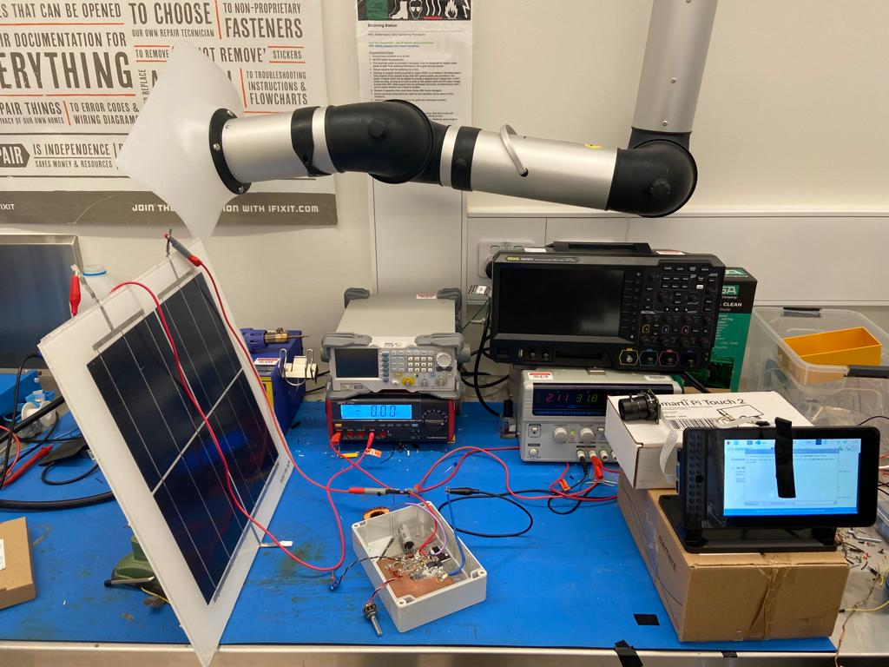

Image 2

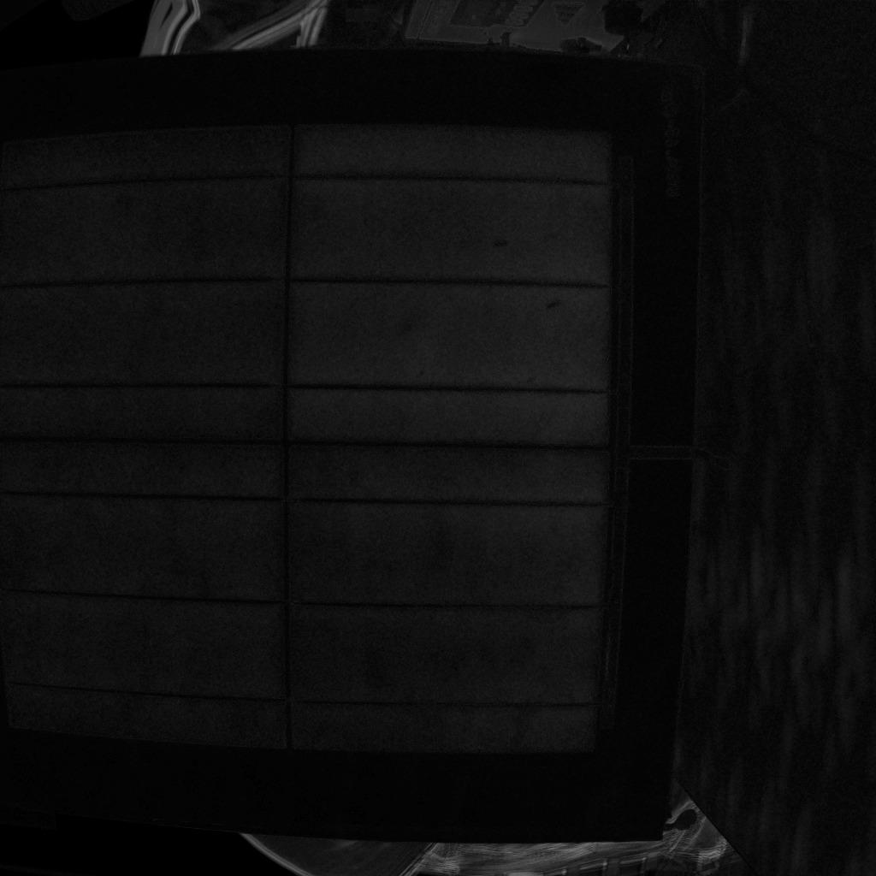

1. Current Deliverables: Refers to immediate tasks that need to be performed prior to the next meeting.